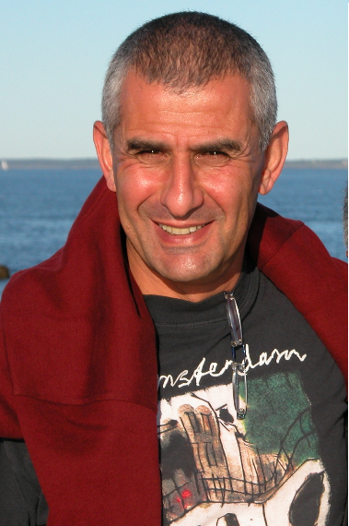

Dr. Eitan ELDAR -- BCBA-D
Head, ABA program, Kibbutzim College
Chairperson, the Israeli Applied Behavior Analysis Association
Israel

Dr. Eitan Eldar (BCBA-D) is the Head of the BACB approved Applied Behavior Analysis program at the Kibbutzim College in Israel, offering 16 courses and a Practicum. He serves as the chairman of the Israeli Applied Behavior Analysis Association (IABA). Published books and papers in the area of Teacher Education and ABA. His book "Applied Behavior Analysis – Principles and Procedures" is the major text book in Hebrew. Developed the model - "Educating through the Physical", integrating physical activity and games as a context for value education and behavioral rehabilitation. Received the award for International Dissemination of Behavior Analysis by SABA (San Diego, May 26, 2007).
Studied the individual inclusion of Autistic children in the regular education system and formulated an inclusion model adopted by the Israeli Ministry of Education. Developed (2006 – 2010) a comprehensive clinical program for Wucailu - an organization for supporting children with ASD - based in Beijing, China. During this period, 3 centers have been established in Beijing – all provide services to families arriving from all over China. Dr. Eldar translated the BACB task list to Hebrew and took part in translating the code of ethics and a comprehensive glossary of ABA terms. Recently, submitted the first proposal for MA-ABA studies in Israel to the ministry of higher education. The proposal has been approved by the Kibbutzim College Academic council and is about to be offered within a year or two.

